MOUSE FRAME CABLE

- PARTS:

QUANTITY: PART #: NOMENCLATURE: LENGTH:

1 PER MACHINE 19283- CABLE, 6-PIN, MINI-DIN, 120 INCHES

1 PER MACHINE 17687- CONNECTOR, MINI-DIN, 6-POS N/A

- ASSEMBLY:

- STRIP ¾-INCH OF OUTER INSULATION FROM THE CABLE.

- TWIST THE SHIELDING INTO A WIRE.

- SLIDE A 5/8-INCH LONG PIECE OF 1/8” SHRINK TUBING OVER THE SHIELD WIRE.

- SHRINK THE TUBING OVER THE SHIELD WIRE.

- STRIP 1/8-INCH OF INSULATION FROM THE ENDS OF THE INDIVIDUAL CABLE WIRES, AND TIN THEM.

- SLIDE A 1-INCH LONG PIECE OF ¼’ SHRINK TUBING OVER THE WIRES AND CABLE.

- SLIDE SEVEN 3/8-INCH LONG PIECES OF 1/8” SHRINK TUBING OVER THE WIRES.

- SOLDER THE WIRES TO THE CONNECTOR ACCORDING TO DIAGRAM 1.

- SLIDE THE SHRINK TUBING PIECESOVER EACH SOLDER JOINT.

- SHRINK THE SMALL SHRINK TUBING INTO PLACE.

- SLIDE THE LARGE SHRINK TUBING OVER THE SOLDER JOINTS.

- SHRINK THE TUBING INTO PLACE.

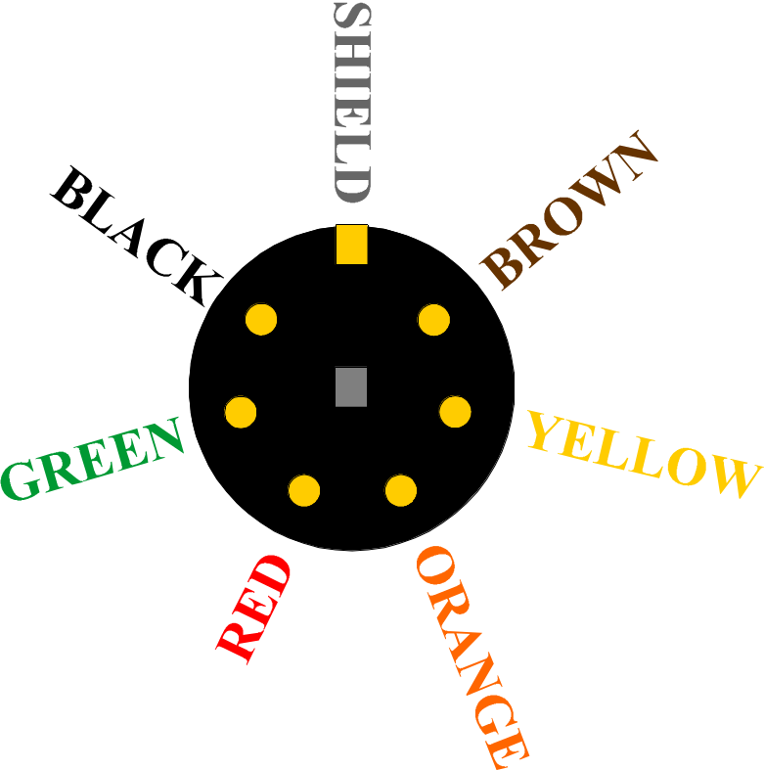

DIAGRAM 1

